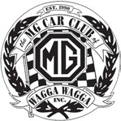
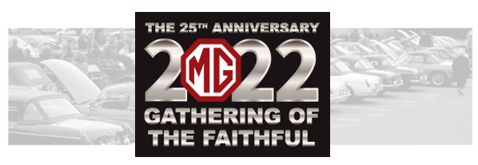
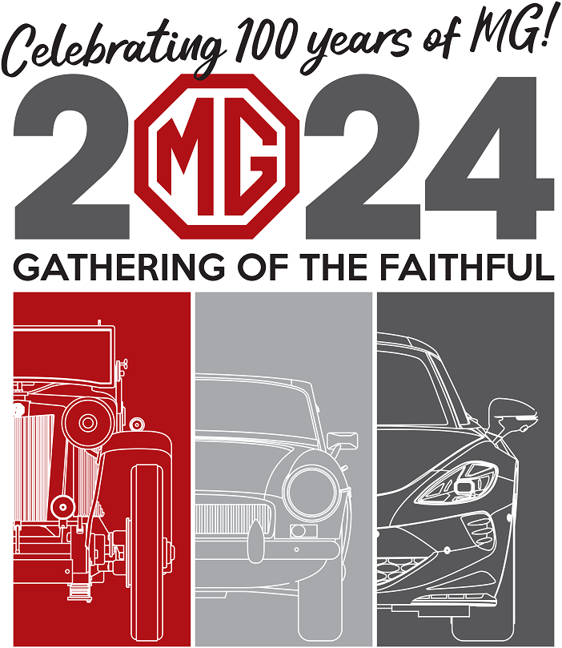
Please bring your own Club name badge

Friday 13th September 2024
6.30pm  For 7pm | GoF Dinner and Dance  To be held this year at the Wagga RSL Club, Dobb St Wagga in the Mirage Room.  As it is Friday 13th, so please wear something spooky. Entertainment by the excellent “Soul Trader”
Saturday 14th September 2024
8.30am | Registration  Meet at the Cross St car park and collect your GOF registration and goody bag. Then take some time out with a short stroll to our wonderful city or stay and have a coffee while we judge cars.
11.00am | Car Judging  All entrants’ vehicles are on public display at the Cross St car park. Cars will be judged Saturday so you can all have a more relaxed start to your Sunday morning.
1.00pm | Fun run  A way to enjoy your MG by sharing your experience with other owners on our local area fun run.
2.30pm | Afternoon tea  After the run, sit back and enjoy a hot tea or coffee, plus a delicious afternoon tea provided by the Country Women’s Association.
Free  For All | Time Out  Spend a relaxing evening exploring the many pubs, clubs and restaurants in Wagga city  .
Sunday 15th September 2024
September
From  8.00am | BBQ breakfast! Start your day with a BBQ breakfast at the Cross St car park, freshly cooked by the Sunrise Rotary Club of Wagga.  “The Gathering of the Faithful” The winners of the trophies are announced.
For more information contact the GOF Committee:

Email gof@mgccwagga.org.au Post GoF Committee
Mobile 0407 911 022 PO Box 6041
Wagga Wagga NSW 2650

See more information online at https://www.mgccwagga.org.au/gof-2024/

